**English Title in USE Symposium** (14 - 16 points)

(1 blank line)

firstname1 familyname11†, firstname2 familyname22, and firstname3 familyname33 (1Affiliation1; 2Affiliation2; 3Affiliation3) (11 points; Affiliations should be written in abbreviated formats such as “Grad. School Eng., ~~ Univ.”)

(2 blank lines)

**1. Main text**

The authors of both invited and contributed papers are asked to prepare a proceedings paper of two pages in PDF (.pdf) and (.docx) formats. The submitted file of the papers will be printed and included in the proceedings.

To fit the format of the proceedings, authors are requested to prepare their manuscript in the exact form shown in this example, in accordance with the following instructions.

1.1 The paper should be typed on two sheets of A4 size (210 mm × 297 mm).

1.2 All materials (including title, authors, their affiliations, figures, tables, references, footnotes, etc.) must fit into an area of 170 mm (width) × 250 mm (depth). The upper, lower, left-hand, and right-hand margins should all be 20 mm. The name of the presenting author must be marked with a dagger (†) as shown in this template. The name of a presenting author applying for a Young Scientist Award must be marked with a double dagger (‡).

1.3 The title should be centered at the top, leaving at least 55 mm from the left-hand edge for insertion of the identification number to be assigned by the technical program committee. Recommended character sizes are 14-16 and 11 points for the title and text, respectively.

Figures (including photographs) and tables should be placed in appropriate positions within the text.

**2. Figures and Tables**

Captions and labels in figures should be in English. The first reference to a figure or table in the text should be in bold, such as **Fig. 1**, **Table I**.

**3. References**

It is recommended to follow the style of references used in JJAP. Examples are shown below. References of related papers contained in recent JJAP special issues of Ultrasonic Electronics are strongly requested.

You can list your e-mail address as a footnote (9 pt)

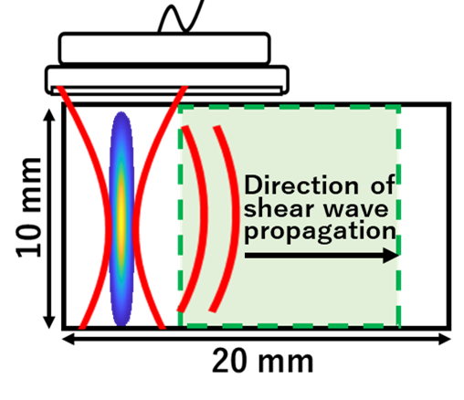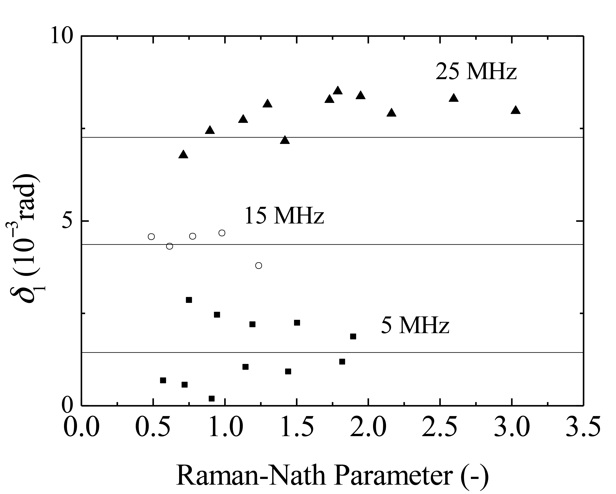

Fig. 1 Retardation of first-order diffracted light vs Raman-Nath parameter.



Fig. 2 Evaluated Nakagami parameter *µ* in livers with different histological characteristics.

**4. Submission of Manuscript**

We ask all participants who wish to present a proceedings paper at USE to send us **final versions of both MS-Word (.docx) and PDF (.pdf) files.** The filename is automatically created when you contribute your paper on-line via "My Page" of the USE website. The deadline for the submission of proceedings papers should be referred to the USE website. Requests of changes or amendments to proceedings papers are no longer acceptable after this date.

**Acknowledgment**

This work was supported by ……..

**References**

1. I. Tomonaga and J. Esaki: Jpn. J. Appl. Phys. **44** (2005) 271.

2. J. Esaki: Jpn. J. Appl. Phys. **46** (2006) 852.

3. H. Goldstein: *Classical Mechanics* (Prentice Hall, NJ, 2002) p. 122.

4. S. Shirakawa, J. Esaki and I. Tomonaga: Jpn. J. Appl. Phys. **46** (2006) 1358.

**(Attention)**

**Authors should confirm the content of the manuscript such as whether the title and the author information (author name(s) and affiliation(s)) correspond to those previously submitted at registration. If you would like to change title or author information, the program committee recommends that you revise the information on the USE Web page before you submit the manuscript of your proceedings paper online.**