**English title in USE symposium** (14–16 points)

(1 blank line)

Firstname1 Familyname11†, Firstname2 Familyname22, and Firstname3 Familyname33* (1Affiliation1; 2Affiliation2; 3Affiliation3) (11 points; Affiliations should be written in abbreviated formats such as “Grad. School Eng., ~~ Univ.”)

(2 blank lines)

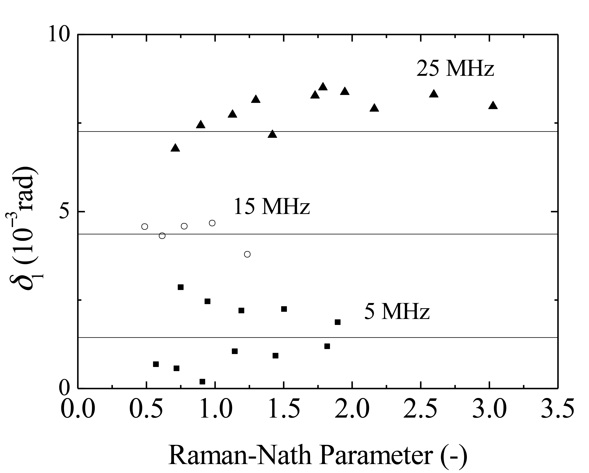

Fig. 1 Retardation of first-order diffracted light vs Raman-Nath parameter.

**1. Main text**

The authors of both invited and contributed papers are asked to prepare a proceedings paper of two pages in PDF (.pdf) and (.docx) formats. The submitted file of the papers will be printed and included in the proceedings.

To fit the format of the proceedings, authors are requested to prepare their manuscript in the exact form shown in this example, in accordance with the following instructions.

**1.1 Page size**

The paper should be typed on **two sheets of A4** size (210 mm × 297 mm).

**1.2 Page format**

All materials (including title, authors, their affiliations, figures, tables, references, footnotes, etc.) must fit into an area of **170 mm (width) × 247 mm (depth)**. The upper margins should be 30 mm, and lower, left-hand, and right-hand margins should all be 20 mm.



Fig. 2 Evaluated Nakagami parameter *µ* in livers with different histological characteristics.

Recommended character size is 11 points for the main text.

**1.3 Title**

A **capital letter** should be used only at the **beginning of the first word**, and for proper nouns, scientific and trade names, and chemical symbols.

The title should be centered at the top, **leaving at least 55 mm** from the left-hand edge for insertion of the identification number to be assigned by the technical program committee.

Recommended character size is 14­–16 points for the title.

**1.4 Authors**

The names of the **presenting author** and the **corresponding author** (supervisor, if the presenting author is a student) should be marked with a **dagger** (†) and an **asterisk** (*), respectively, as shown in this template. The name of a presenting author applying for a **Young Scientist Award** must be marked with a **double dagger** (‡).

E-mail: †abc@def.com, *def@def.com (9 points; The presenting author and the corresponding author (supervisor, if the presenting author is a student) should list their e-mail address as a footnote.)

The **presenting author** and the **corresponding author** should list their **e-mail addresses** as a footnote.

**2. Figures and tables**

Figures (including photographs) and tables should be placed in appropriate positions within the text. Captions and labels in figures should be in English. The **first reference to a figure or table** in the text should be in bold, such as **Fig. 1**, **Table I**.

**3. Citations and references**

Place numbers with a closing parenthesis as a superscript to cite literature in the main text, e.g., 1), 2,3), 4–7,11), after any punctuation mark.

It is recommended to follow the style of references used in JJAP. Examples are shown in the Reference section.

**(Attention)**

**Authors should confirm the content of the manuscript such as whether the title and the author information (author name(s) and affiliation(s)) correspond to those previously submitted at registration. If you would like to change title or author information, the program committee recommends that you revise the information on the USE website before you submit the manuscript of your proceedings paper online.**

References of related papers contained in recent JJAP special issues of Ultrasonic Electronics are strongly requested.

**4. Submission of manuscript**

We ask all participants who wish to present a proceedings paper at USE to send us **final versions** of both **MS-Word (.docx)** and **PDF (.pdf) files**. The filename is automatically created when you contribute your paper on-line via “My Page” of the USE website.

The deadline for the submission of proceedings papers should be referred to the USE website. Requests of changes or amendments to proceedings papers are no longer acceptable after this date.

**Acknowledgment**

This work was supported by …

**References**

1. I. Tomonaga and J. Esaki, Jpn. J. Appl. Phys. **44**, 271 (2005).
2. S. Shirakawa, J. Esaki, and I. Tomonaga, Jpn. J. Appl. Phys. **46**, 1358 (2006).
3. J. Esaki, Jpn. J. Appl. Phys. **46**, 852 (2006).
4. H. Sakurai, K. Takada, and E. Takayama-Muromachi, Oyo Buturi **74**, 22 (2005) [in Japanese].
5. H. Goldstein, *Classical Mechanics* (Prentice Hall, NJ, 2002) p. 122.
6. T. Takenouchi, *Handotai* (Semiconductors) (Shokabo, Tokyo, 1964) p. 83 [in Japanese].
7. H. Nomura and T. Imaizumi, Proc. 43rd Symp. Ultrasonic Electronics, 2022, 1Pb4-3.
8. S. Kouyama, K. Okubo, and N. Tagawa, 2019 IEEE Int. Ultrason. Symp., 2019, p. 603.
9. K. Hoh and Y. Yasuda, IEICE Tech. Rep. ED93-89 (1993) [in Japanese].
10. Y. Takeda and Y. Ito, Proc. 1999 Spring Meet. Acoustical Society of Japan, 1999, p. 873 [in Japanese].